Challenge
LO3 – Designing
Malamski,Dimitar D.S.
mitemalamata@gmail.com

Contents
Contents 1
Introduction 2
Sprints 2
Sprint 5 2
Evidence 1 - Designing and Comparing Alternative Model Architectures 2
Evidence 2 - Designing an Improved Recommendation Pipeline Using CLIP Embeddings 5
Sprint 4 6
Evidence 1 - Designing the Embedding-Based Recommendation Pipeline 6
Evidence 2 - Designing a Repeatable Recommendation Evaluation Framework 7
Sprint 3 8
Evidence 1 - Designing the model approach using transfer learning 8
Evidence 2 - Designing the training strategy for a small dataset 9
Sprint 1 & 2 9

Introduction
This document presents the evidence for Learning Outcome 3 ( Designing ) in my Challenge project – Outfit Recommendation System. The purpose of this document is to show how I demonstrated this learning outcome by designing an iterative modelling process for an interpretable AI solution in the context of fashion style classification and outfit recommendation. The evidence is organized by sprint, with each section describing the activity, the result, and why it is relevant to the learning outcome.

Sprints

Sprint 5

Evidence 1 - Designing and Comparing Alternative Model Architectures
What this evidence is
This evidence shows how I designed and evaluated alternative model architectures to improve the style classification component of the outfit recommendation system.
What I did
After the recommendation evaluation framework showed that style classification was the main bottleneck of the system, I designed an architecture comparison experiment. The goal was to determine whether changing the model architecture could improve real-world performance.
I selected three different architectures: ResNet34, MobileNetV3 Large, and EfficientNet-B0. To ensure a fair comparison, all models were trained using the same training dataset, validation set, testing procedure, and evaluation metrics. I then evaluated each model on both the curated test set and the real-world evaluation set.
The comparison showed that MobileNetV3 Large achieved the best real-world performance while also having a significantly smaller model size than ResNet34.
Result
This resulted in a systematic model selection process rather than choosing an architecture based solely on popularity or benchmark results. The experiment showed that MobileNetV3 Large achieved the best balance between model size and real-world classification performance. Based on these findings, MobileNetV3 Large was selected as the new style classifier for the recommendation system.
Why this is relevant to the Learning Outcome
This demonstrates Designing because I created an iterative improvement process based on findings from previous evaluations. I explored multiple architectural alternatives, compared them using a controlled experimental setup, and selected the most suitable model for the defined domain. The design decision was driven by real-world performance rather than only internal test accuracy, making the solution more relevant for the intended use case.
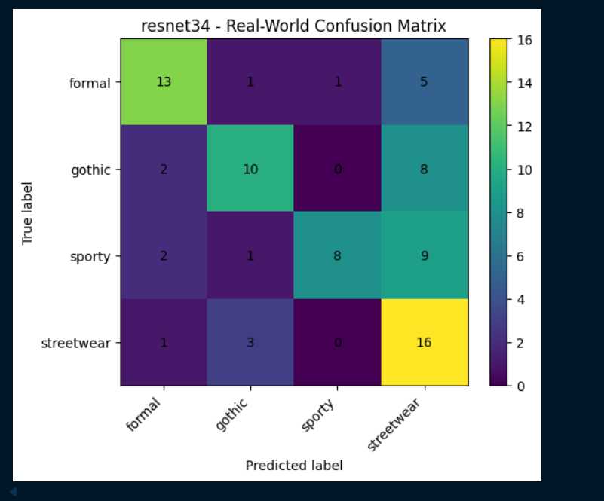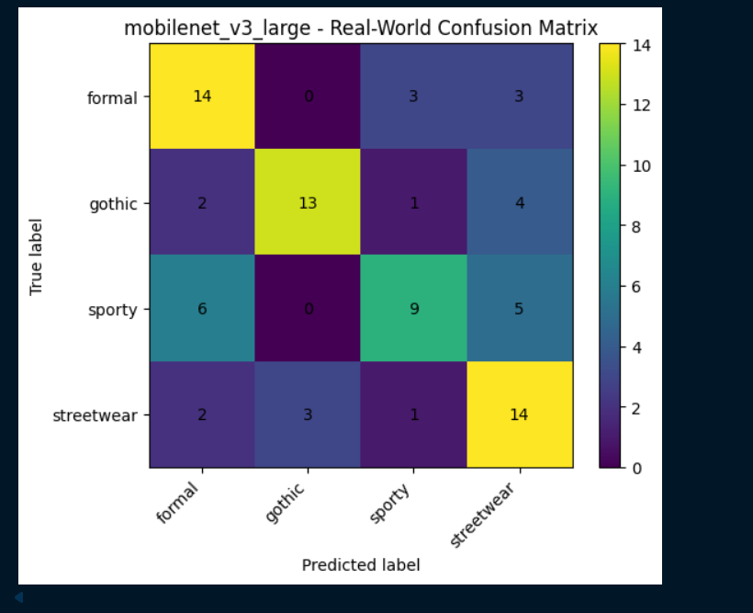
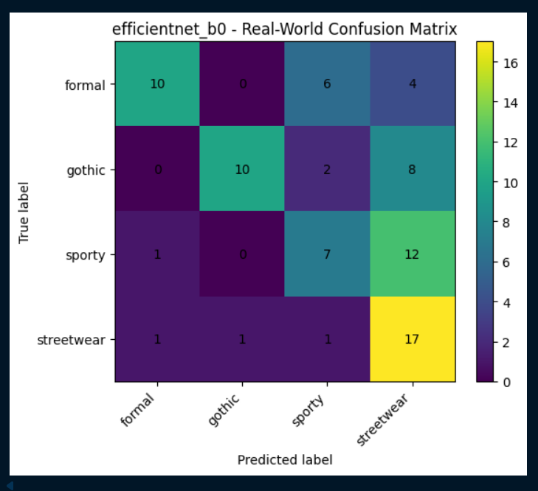

Evidence 2 - Designing an Improved Recommendation Pipeline Using CLIP Embeddings
What this evidence is
This evidence shows how I redesigned the recommendation ranking stage to improve recommendation quality and visual coherence.
What I did
After evaluating the recommendation system, I found that visual coherence was weaker than structural validity. The recommendations were often logically correct, but the selected items did not always appear visually compatible.
To address this issue, I designed a new recommendation ranking experiment using CLIP image embeddings. The existing pipeline used ResNet34 embeddings with cosine similarity. To isolate the effect of the embedding extractor, I kept the style classifier, clothing type classifier, recommendation catalogue, confidence thresholds, evaluation dataset, and ranking method unchanged. Only the embedding model was replaced.
The redesigned pipeline used CLIP embeddings together with cosine similarity to rank recommendation candidates.
Result
This resulted in a measurable improvement in recommendation quality. Visual coherence improved from 1.3750 to 1.6250, while overall recommendation quality increased from 1.40625 to 1.5625. The number of bad recommendations also decreased significantly.
Based on these results, CLIP embeddings were selected as the new recommendation ranking method for the final prototype.
Why this is relevant to the Learning Outcome
This demonstrates Designing because I iteratively improved the recommendation system based on previous evaluation findings. I redesigned a specific component of the pipeline, tested the effect in a controlled manner, and selected the approach that produced better results. The experiment shows how data-driven design decisions were used to improve the interpretability and effectiveness of the AI solution within the fashion recommendation domain.
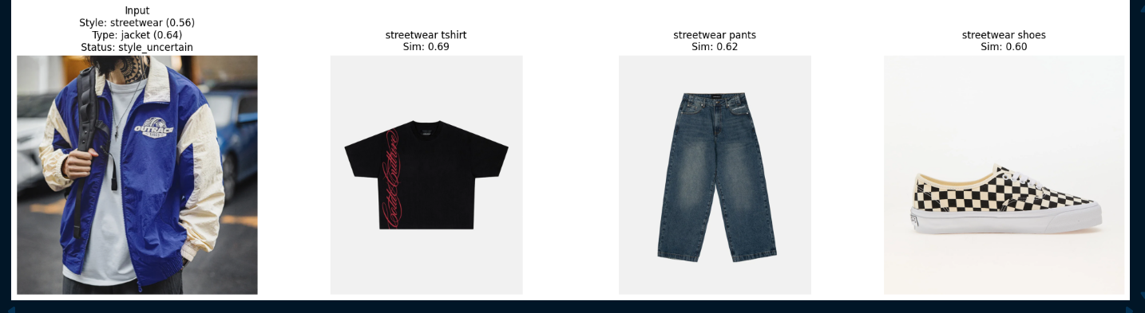

Sprint 4

Evidence 1 - Designing the Embedding-Based Recommendation Pipeline
What this evidence is
This evidence shows how I designed the recommendation pipeline after creating the style and clothing type classifiers.
What I did
After the baseline classifiers were created, I designed a pipeline that combines style prediction, clothing type prediction, and visual similarity. The system first predicts the style and type of the input image. Then it filters the catalogue to items with the same predicted style, excludes items with the same predicted clothing type, and ranks the remaining items using ResNet34 embeddings and cosine similarity.
Result
This resulted in a more structured recommendation process. Instead of randomly selecting items, the system could recommend items based on clear steps: same style, different clothing type, and visual similarity. This also made the recommendations easier to understand, because I could explain why each item was selected.
Why this is relevant to the Learning Outcome
This demonstrates Designing because I created an interpretable AI pipeline for the fashion recommendation domain. The design connects the classification models to the recommendation task in a clear and explainable way, while also leaving room for future improvements.
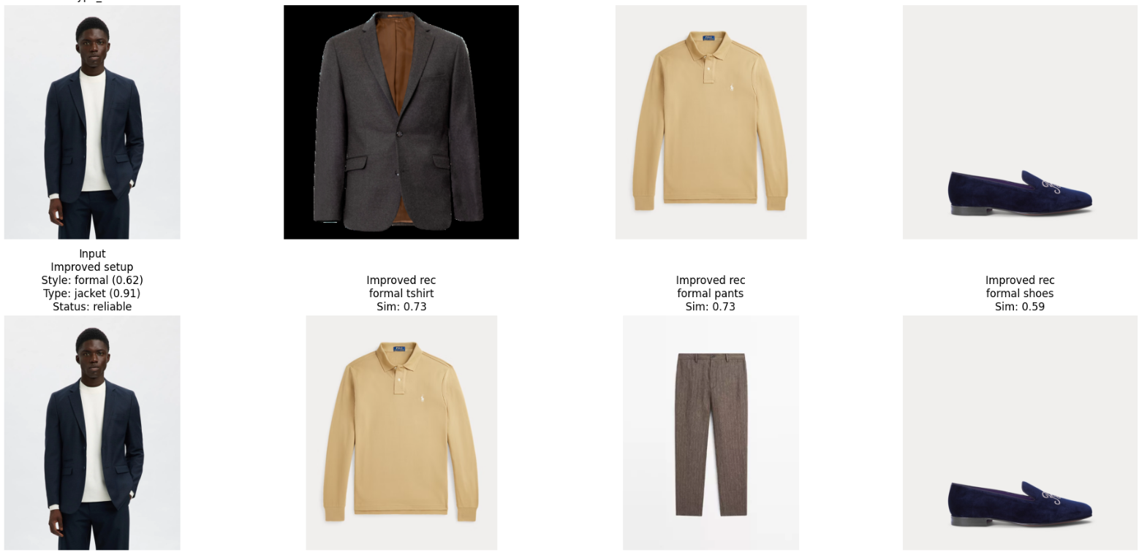

Evidence 2 - Designing a Repeatable Recommendation Evaluation Framework
What this evidence is
This evidence shows how I designed a repeatable evaluation framework for testing the recommendation system.
What I did
After testing recommendations visually, I noticed that only looking at a few examples was not structured enough. Because of this, I designed an evaluation framework using 32 balanced real-world examples. The examples were selected from 4 styles and 4 clothing types, with 2 examples for each combination. I also designed manual scoring criteria from 0 to 2 for structural validity, style consistency, visual coherence, confidence warning usefulness, and overall recommendation quality.
Result
This resulted in a more systematic way to evaluate the recommendation system. The framework made it possible to compare recommendation quality across styles and clothing types. It also showed that the system was strong in structural validity, but weaker in style consistency, visual coherence, and overall quality.
Why this is relevant to the Learning Outcome
This demonstrates Designing because I created an iterative evaluation process that can be reused in future versions of the project. Instead of judging recommendations only by visual inspection, I designed a method that makes the results more comparable and meaningful for the fashion recommendation domain.
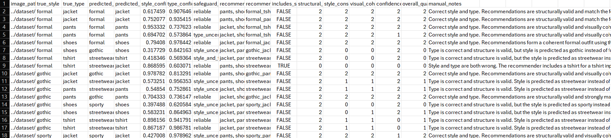

Sprint 3

Evidence 1 - Designing the model approach using transfer learning
What this evidence is
This evidence shows how I designed the model architecture for the fashion style classification task using transfer learning.
What I did
Instead of training a deep learning model from scratch, I analyzed the limitations of the dataset, particularly its relatively small size, and designed the solution around transfer learning. I selected a pretrained ResNet model as the base architecture, since it already contains learned visual features from a large-scale dataset (ImageNet). I then adapted the model by replacing the final classification layer so that it outputs predictions for the four style classes in this project.
Result
This resulted in a more efficient and realistic model design that is better suited for small datasets. By reusing pretrained features, the model was able to learn meaningful patterns without requiring a large amount of training data.
Why this is relevant to the Learning Outcome
This demonstrates designing because I made a deliberate architectural decision based on the constraints of the dataset. Instead of applying a default approach, I selected and adapted a model structure that fits the problem context and improves the feasibility of the solution.
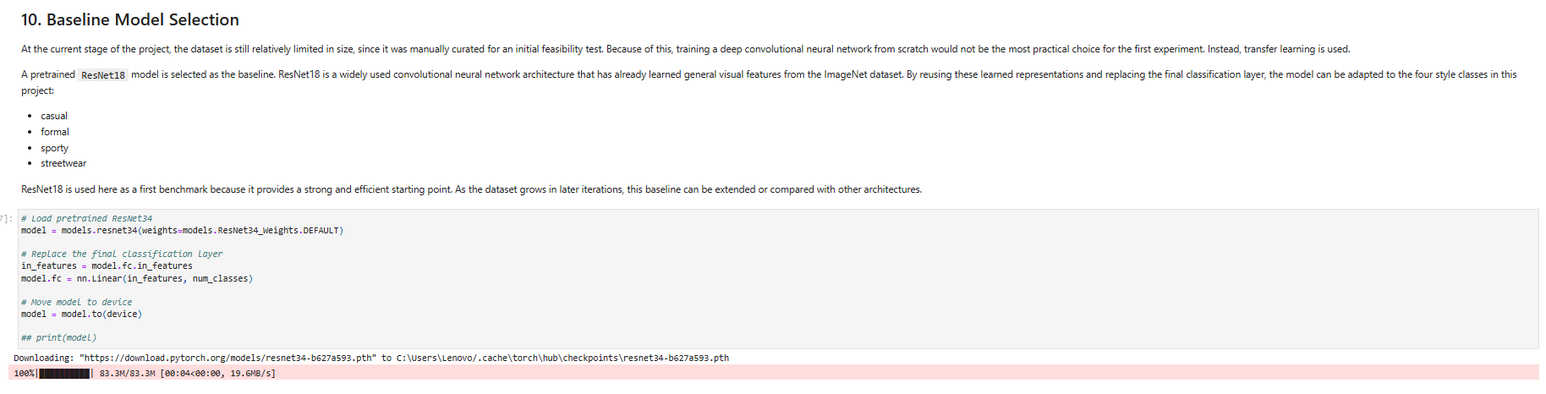

Evidence 2 - Designing the training strategy for a small dataset
What this evidence is
This evidence shows how I designed the training process to reduce overfitting and improve generalization on a small dataset.
What I did
After selecting a pretrained ResNet model, I designed the training strategy by freezing all pretrained layers and training only the final classification layer. This decision was based on the risk of overfitting due to the limited dataset size. By keeping the pretrained feature extractor fixed and only updating the final layer, the model focuses on adapting high-level representations to the specific style classification task without overfitting to noise in the data.
Result
This resulted in a stable and efficient training process that reduced the risk of overfitting while still allowing the model to learn task-specific patterns. It also simplified the training setup and made the baseline experiment more reliable.
Why this is relevant to the Learning Outcome
This demonstrates designing because I intentionally structured the training process based on the characteristics of the dataset. The decision to freeze layers and fine-tune only the final layer reflects a thoughtful design choice aimed at balancing model complexity and generalization.
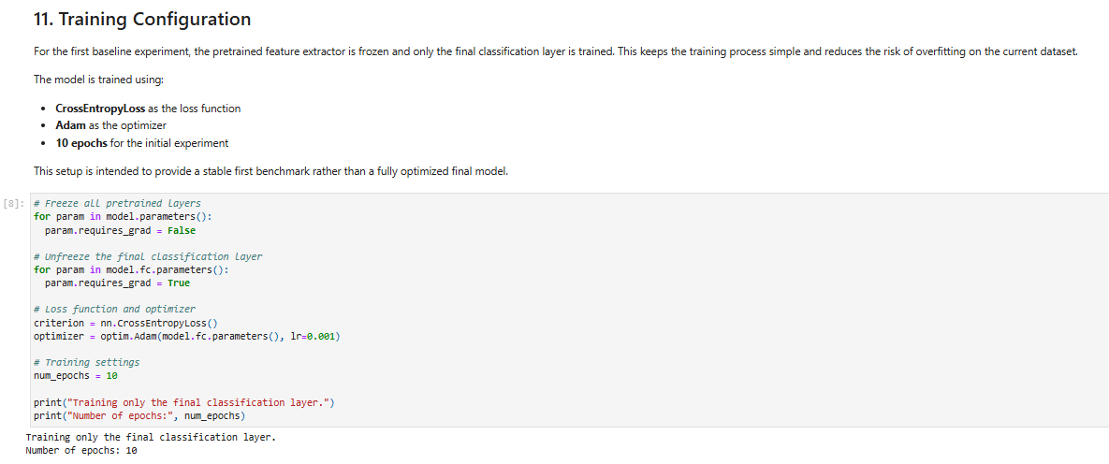

Sprint 1 & 2
There was no work done in those sprints, since the projects starts from Sprint 3.

